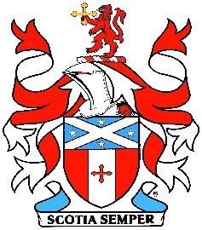
Saint Andrew’s Society of Mid-Maryland, Inc.
Celebrating Scottish Life and Culture

“Throwback Burns” Supper
Saturday, February 27, 2021

What’s on Your Table?
You’ve made some wonderful Scottish dishes for your Burns Supper; now show them off with some inviting ‘tablescape.’ Use your imagination!

Need more ideas?
Check out Margaret’s pinterest page or search on-line.
https://www.pinterest.com/marghallaren/burns-nicht/

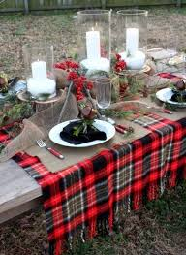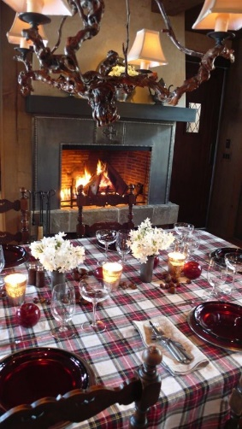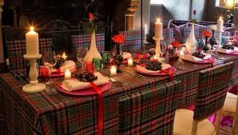

Disclaimer of Endorsement
The St. Andrew’s Society of Mid-Maryland provides links to other websites for informational purposes and the convenience of its users. The Society does not endorse individual vendors, products, services, or organizations. Any reference to any vendor, products or services by trade name, trademark, or manufacturer, or otherwise does not constitute or imply the endorsement, recommendation or approval of the Society. Also, the Society does not control or guarantee the currency, accuracy, relevance, or completeness of information found on linked, external websites.

