St. Andrew’s Society of Mid-Maryland “Throwback Burns” Supper Saturday, February 27, 2021

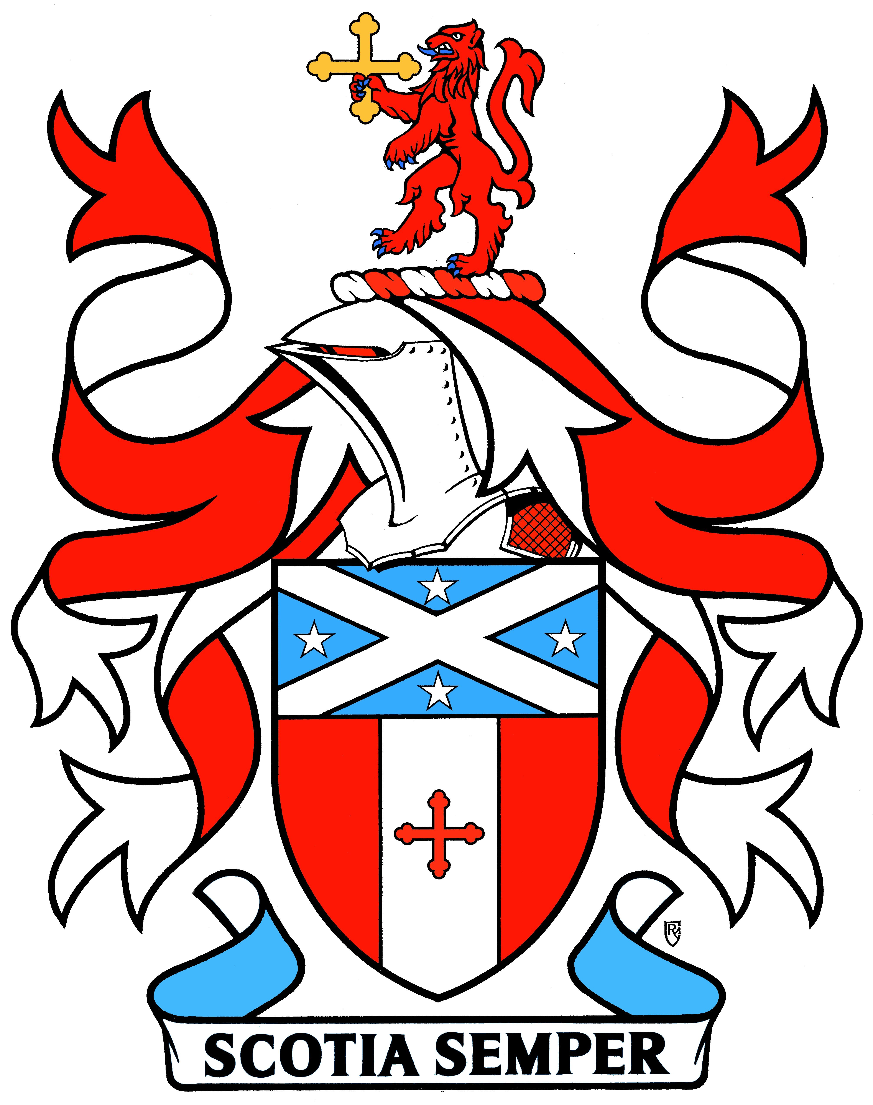
Possible Resources for Ingredients

Burns Supper in a Box
- Scottish Gourmet https://www.scottishgourmetusa.com/category/haggis-usa
- Amazon https://www.amazon.com/Caledonian-Kitchen-Complete-Robert-Presentation/dp/B019CR54IO/ref=sr_1_2?dchild=1&gclid=EAIaIQobChMI7Y3Jz5CQ7gIVAfSzCh1OcgjhEAAYAiAAEgJ_EfD_BwE&hvadid=178702310815&hvdev=c&hvlocphy=9009564&hvnetw=g&hvqmt=e&hvrand=4897781407771603464&hvtargid=kwd-3858681210&hydadcr=4823_9628281&keywords=caledonian+kitchen&qid=1610246183&sr=8-2&tag=googhydr-20

Haggis – Regular and Vegetarian
- Scottish Gourmet https://www.scottishgourmetusa.com/category/haggis-usa
- MacSween – Canned Vegetarian Haggis https://www.macsween.co.uk/us/products/scottish-veggie-crumble/
- Caledonian Kitchen Haggis (Canned)
Regular in Lamb, Sirloin Beef, and Highland Beef and Vegetarian Haggis
Available at:
https://igourmet.com/products/highland-beef-haggis
https://www.walmart.com/ip/Caledonian-Kitchen-Highland-Sirloin-Haggis-14-5-oz/620877400
https://scottishcountryshop.com/products/haggis-highland-beef-canned
https://www.taylorscroft.com/products/caledonian-kitchen-haggis
https://scottishtartansgiftshop.com/products/caledonian-kitchen-haggis
https://www.thescottishgrocer.com/collections/haggis

Meatless Grounds for Preparing Harriett’s Vegetarian Haggis:
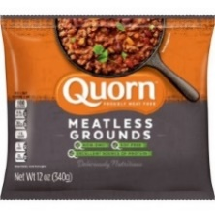
In Maryland available at Common Market, Giant, Walmart, and Weiss (check first as not all may carry this

Scottish Fare – meats, fish, pies, sweets, tea, table décor, and more!
- Scottish Gourmet https://www.scottishgourmetusa.com/
- Cameron’s Scottish Market (Note: Has been purchased by Tastefully British)
https://www.facebook.com/Cameronsscottish/
https://www.facebook.com/TastefullyBritish/
- Parkers https://parkersbritishinstitution.com/
- Igourmet https://igourmet.com/blogs/country-cuisine-guide/scottish-cuisine-guide
- Harney & Sons https://www.harney.com/collections/scottish-blends
- teadog.com https://www.harney.com/collections/scottish-blends?utm_campaign=1%2F15%20Weekly%20Email%20Remail%20%28V9dd9q%29&utm_medium=email&utm_source=Engaged%209020%20Days%20Email&_ke=eyJrbF9jb21wYW55X2lkIjogIkNOc3pVQyIsICJrbF9lbWFpbCI6ICJtYXJnYXJldEBoYWxsYXJlbi5jb20ifQ%3D%3D

Disclaimer of Endorsement
The St. Andrew’s Society of Mid-Maryland provides links to other websites for informational purposes and the convenience of its users. The Society does not endorse individual vendors, products, services, or organizations. Any reference to any vendor, products or services by trade name, trademark, or manufacturer, or otherwise does not constitute or imply the endorsement, recommendation or approval of the Society. Also, the Society does not control or guarantee the currency, accuracy, relevance, or completeness of information found on linked, external websites.

